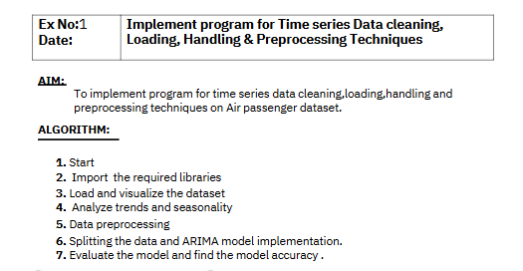
Program
# Import required libraries
import pandas as pd
import matplotlib.pyplot as plt
import seaborn as sns

# Load the Air Passenger dataset
url = "/content/airline-passengers.csv"
data = pd.read_csv(url, parse_dates=['Month'], index_col='Month')

# Display the first few rows of the dataset
print("Dataset Preview:")
print(data.head())

# Plot the time series data
plt.figure(figsize=(12, 6))
plt.plot(data.index, data['Passengers'], marker='o', linestyle='-')
plt.title('Monthly Air Passengers (1949-1960)', fontsize=16)
plt.xlabel('Date', fontsize=12)
plt.ylabel('Number of Passengers (in thousands)', fontsize=12)
plt.grid()
plt.show()

# Visualizing trends and seasonality using a rolling mean
data['Passengers_MA'] = data['Passengers'].rolling(window=12).mean() # 12-month rolling mean

plt.figure(figsize=(12, 6))
plt.plot(data.index, data['Passengers'], label='Original Data', color='blue')
plt.plot(data.index, data['Passengers_MA'], label='12-Month Rolling Mean', color='orange', linewidth=2)
plt.title('Air Passengers with Trend (Rolling Mean)', fontsize=16)
plt.xlabel('Date', fontsize=12)
plt.ylabel('Number of Passengers (in thousands)', fontsize=12)
plt.legend()
plt.grid()
plt.show()

Dataset Preview:
Passengers
Month
1949-01-01 112
1949-02-01 118
1949-03-01 132
1949-04-01 129
1949-05-01 121

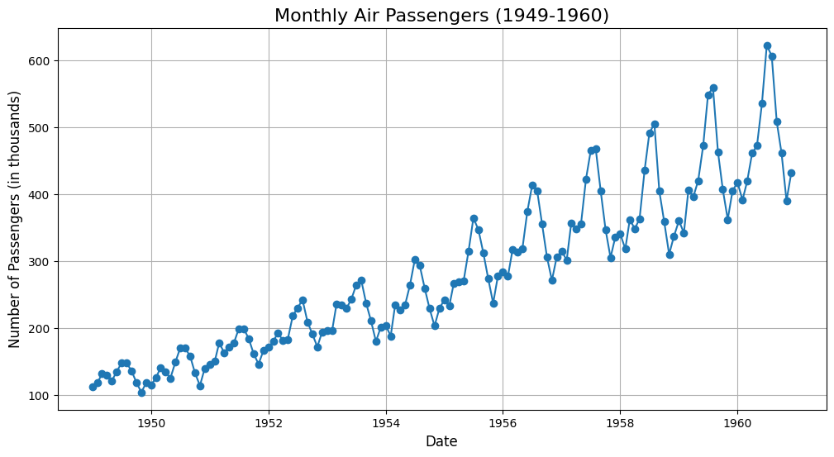
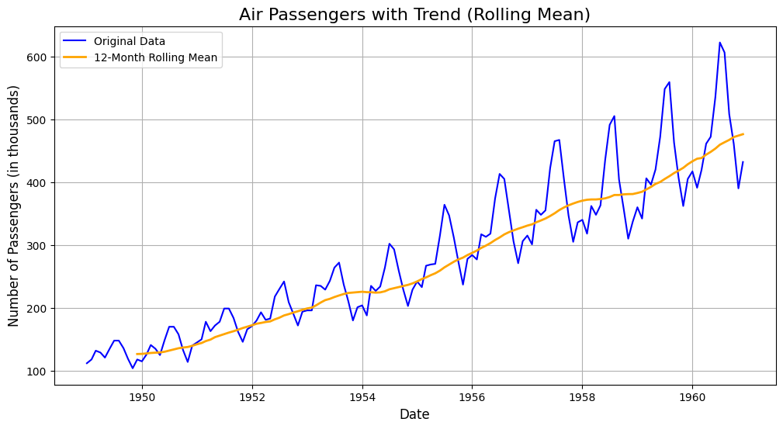
# Import required libraries
from sklearn.preprocessing import MinMaxScaler

# Check for missing values
print("Checking for missing values:")
print(data.isnull().sum())

# Handle missing values (if any) - Filling with forward fill as an example
data['Passengers'] = data['Passengers'].fillna(method='ffill')

# Normalize the data using MinMaxScaler
scaler = MinMaxScaler(feature_range=(0, 1))
data['Passengers_Normalized'] = scaler.fit_transform(data[['Passengers']])

# Display the preprocessed data
print("\nPreprocessed Data (First 5 Rows):")
print(data.head())

# Visualize the normalized data
plt.figure(figsize=(12, 6))
plt.plot(data.index, data['Passengers_Normalized'], color='green', linestyle='-', marker='o')
plt.title('Normalized Air Passengers Data', fontsize=16)
plt.xlabel('Date', fontsize=12)
plt.ylabel('Normalized Passengers', fontsize=12)
plt.grid()
plt.show()

Checking for missing values:
Passengers 0
Passengers_MA 11
dtype: int64

Preprocessed Data (First 5 Rows):
Passengers Passengers_MA Passengers_Normalized
Month
1949-01-01 112 NaN 0.015444
1949-02-01 118 NaN 0.027027
1949-03-01 132 NaN 0.054054
1949-04-01 129 NaN 0.048263
1949-05-01 121 NaN 0.032819
<ipython-input-2-c0f3d9447aaf>:9: FutureWarning: Series.fillna with 'method' is deprecated and will raise in a future version. Use obj.ffill() or obj.bfill() instead.
data['Passengers'] = data['Passengers'].fillna(method='ffill')

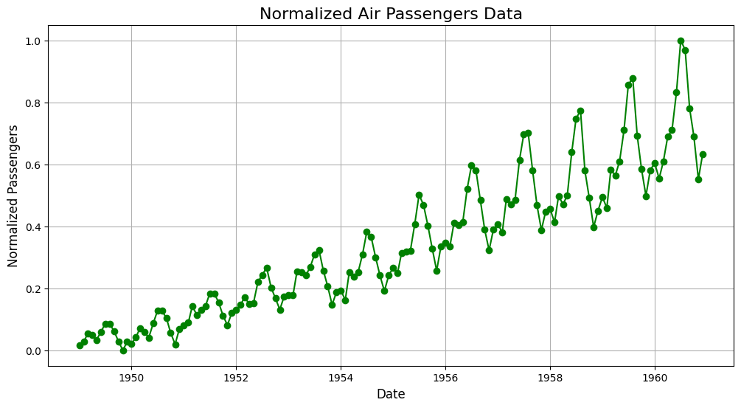
# Import required libraries
from statsmodels.tsa.arima.model import ARIMA
from sklearn.metrics import mean_squared_error
import numpy as np

# Split the dataset into training and testing sets
train_size = int(len(data) * 0.8) # 80% training, 20% testing
train, test = data['Passengers'][:train_size], data['Passengers'][train_size:]

# Fit the ARIMA model (parameters can be tuned for better performance)
model = ARIMA(train, order=(2, 1, 2)) # ARIMA(p, d, q)
arima_model = model.fit()

# Forecast on the test data
forecast = arima_model.forecast(steps=len(test))
forecast_index = test.index

# Evaluate model performance
mse = mean_squared_error(test, forecast)
print(f"Mean Squared Error (MSE): {mse}")
print(f"Root Mean Squared Error (RMSE): {np.sqrt(mse)}")

# Plot the results
plt.figure(figsize=(12, 6))
plt.plot(train.index, train, label='Training Data', color='blue')
plt.plot(test.index, test, label='Test Data', color='green')
plt.plot(forecast_index, forecast, label='Forecast', color='red', linestyle='--')
plt.title('ARIMA Model - Air Passengers Forecast', fontsize=16)
plt.xlabel('Date', fontsize=12)
plt.ylabel('Number of Passengers', fontsize=12)
plt.legend()
plt.grid()
plt.show()

/usr/local/lib/python3.11/dist-packages/statsmodels/tsa/base/tsa_model.py:473: ValueWarning: No frequency information was provided, so inferred frequency MS will be used.
self._init_dates(dates, freq)
/usr/local/lib/python3.11/dist-packages/statsmodels/tsa/base/tsa_model.py:473: ValueWarning: No frequency information was provided, so inferred frequency MS will be used.
self._init_dates(dates, freq)
/usr/local/lib/python3.11/dist-packages/statsmodels/tsa/base/tsa_model.py:473: ValueWarning: No frequency information was provided, so inferred frequency MS will be used.
self._init_dates(dates, freq)
Mean Squared Error (MSE): 6808.3970474928465
Root Mean Squared Error (RMSE): 82.51301138301066

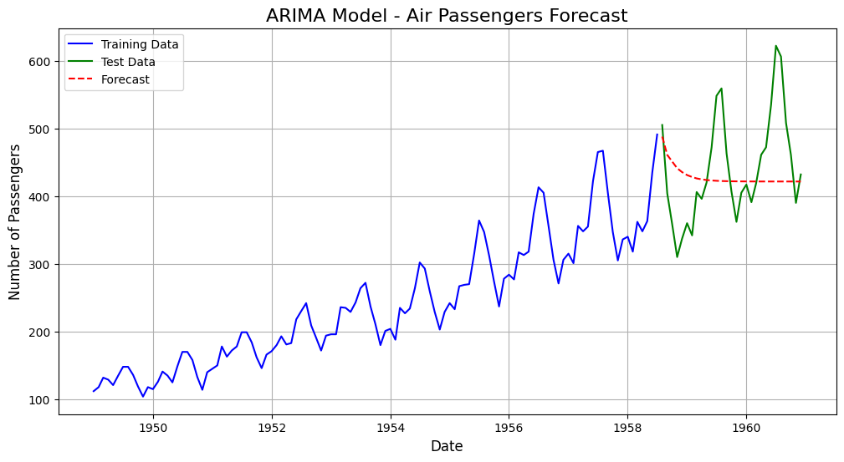
from sklearn.metrics import mean_absolute_error, mean_squared_error, r2_score
import numpy as np

# Calculate performance metrics
mae = mean_absolute_error(test, forecast)
mse = mean_squared_error(test, forecast)
rmse = np.sqrt(mse)
r2 = r2_score(test, forecast)

# Print the metrics
print("Model Performance Metrics:")
print(f"Mean Absolute Error (MAE): {mae}")
print(f"Mean Squared Error (MSE): {mse}")
print(f"Root Mean Squared Error (RMSE): {rmse}")
print(f"R-squared (R2): {r2}")

# Visualize Actual vs Predicted
plt.figure(figsize=(12, 6))
plt.plot(test.index, test, label='Actual', color='green')
plt.plot(forecast_index, forecast, label='Forecast', color='red', linestyle='--')
plt.title('Actual vs Predicted - Model Evaluation', fontsize=16)
plt.xlabel('Date', fontsize=12)
plt.ylabel('Number of Passengers', fontsize=12)
plt.legend()
plt.grid()
plt.show()

Model Performance Metrics:
Mean Absolute Error (MAE): 63.545311250127014
Mean Squared Error (MSE): 6808.3970474928465
Root Mean Squared Error (RMSE): 82.51301138301066
R-squared (R2): -0.11530974198470823

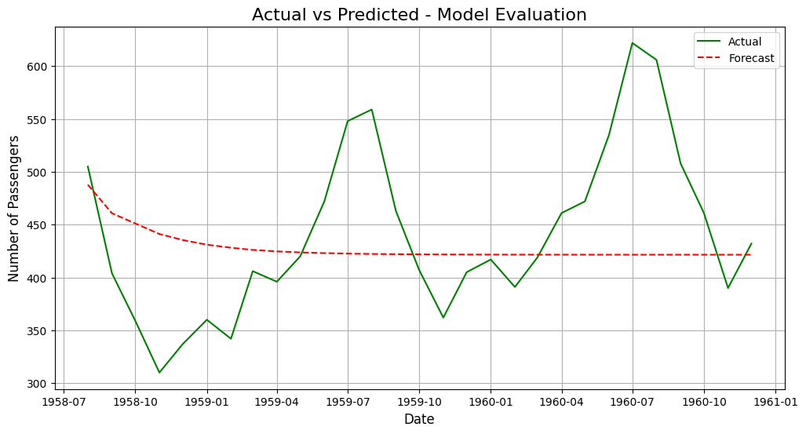
Model Accuracy: 85.78%

RESULT:

Thus the program for time series data cleaning, loading, handling & preprocessing techniques on Air passengers has been implemented successfully.

